**User’s Manual**

* **General information------------------------------------------------------------------------------- 2**

**1.1 System Overview**

**1.2 Organization of the Manual**

* **System summary----------------------------------------------------------------------------------- 2**

**2.1 System Configuration**

**2.2 User Access Level**

* **Getting started---------------------------------------------------------------------------------------3**

**3.1 Installation and BLE connection**

**3.2 Using the system**

**3.3 Exit System**

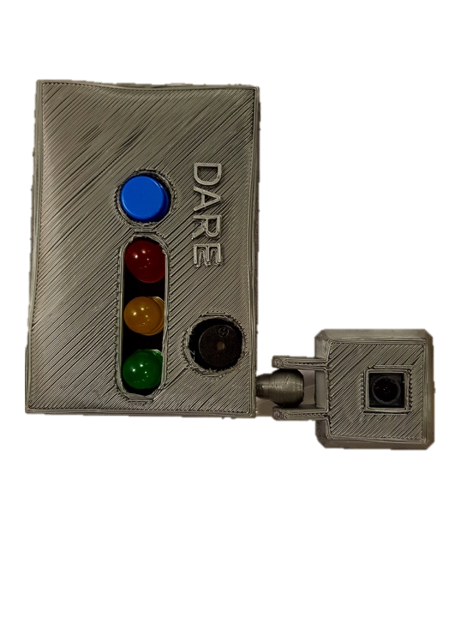

* **Special instructions for Error correction----------------------------------------------------3**

General information

**1.1 System Overview**

DARE is a monitoring device that uses a camera to detect a driver’s alertness level. Depending on the severity of his sleepiness, it will send the driver a visual or acoustic alarm to prevent any potential accident. This device can also be connected to your iPhone over Bluetooth with our DARE application to get access to more advanced features.

**1.2 Organization of the Manual**

This manual consists of four sections: General information, System summary, Getting started and Special instructions for Error correction.

* General information: explains why such product was realized.
* System summary: gives a brief overview of the product. First, it explains what the hardware and software requirements for using this product are. Then, it outlines the user access level.
* Getting started: explains how to set up the device in the car and how to connect the device your iPhone via Bluetooth. Additionally, this section also explains how the device should normally react to the user’s actions.
* Special instructions for Error correction: provides detailed instruction on what to do when any contingency or error in the system occurs.

System Summary

**2.1 System Configuration**

DARE starts working automatically once plugged in the cigar lighter. If the user has an iPhone with iOS 11 or a higher version, the product can be connected to the DARE app via Bluetooth.

**2.2 User Access Level**

Everyone can use the product, but it is highly recommended to read this manual before starting your journey.

Getting Started

**3.1 Installation and BLE connection**

The installation process is simple, just put dare on your dashboard and plug it into the cigar lighter. That’s it, you are safe to go. The latest mobile application version can be downloaded from the Apple store. After opening the App, a music button on the right bottom of the screen is displayed, which allows the user to choose their favourite song as an alarm. To connect your phone to the device, the user simply needs to press the “Connect” button in the middle of the home page and choose “Raspberry Pi”. That is all.

**3.2 Using the system**

The driver needs to place the device on the dashboard such that the camera faces the driver. Once the device is powered by being plugged in the cigar lighter, LEDs blink alternatingly to indicate that the system is booting up. Then, the green LED turns once the system is ready to start drowsiness detection, and the device can be connected to the App. If the connection is set up successfully, the user will see the message “connected” displayed on the phone. Otherwise, the message “connection lost” will be shown.

DARE is able to detect yawning as well as sleeping. If the driver is asleep, the buzzer will be triggered immediately, and the App will play music for one minute. If the driver starts yawning instead of falling asleep directly, the first yawn will be indicated by the yellow LED blinking. After that, the driver will be warned by the red LED blinking.

**3.3 Exit System**

DARE can be quit by powering off the device directly and closing the app.

Special instructions for Error correction

If any unexpected error occurs in the system, there is a reset button in the front side of the device to reset the whole system.